Resume:

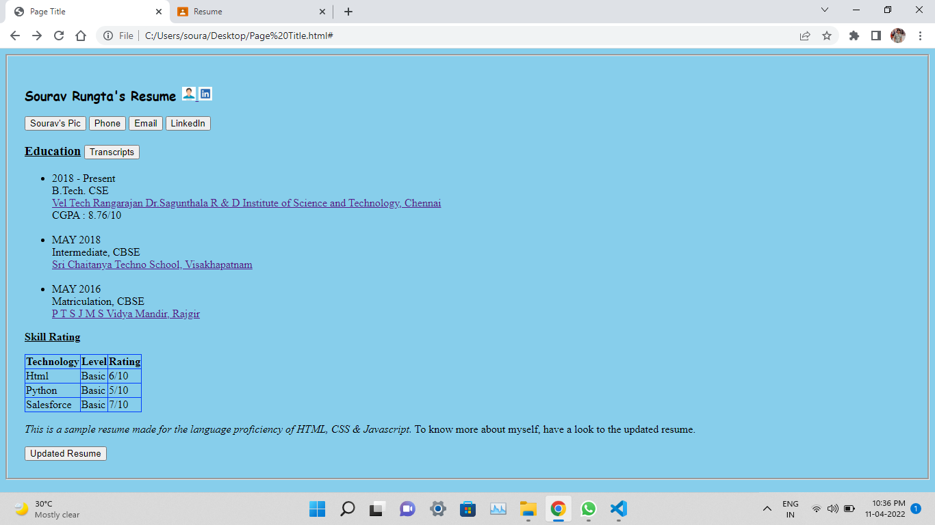

When the curser is placed in profile icon & linkedin icon the color changed to show that cursor is in profile icon or in linkedin icon.

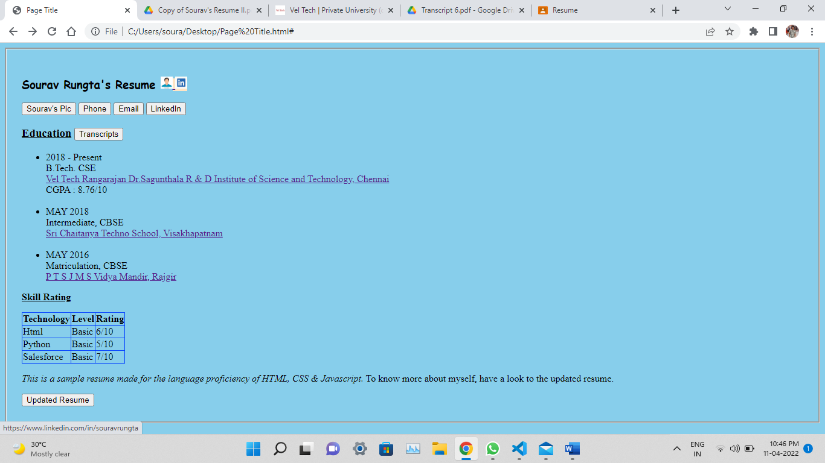

The Phone button and Email Button is working in this way.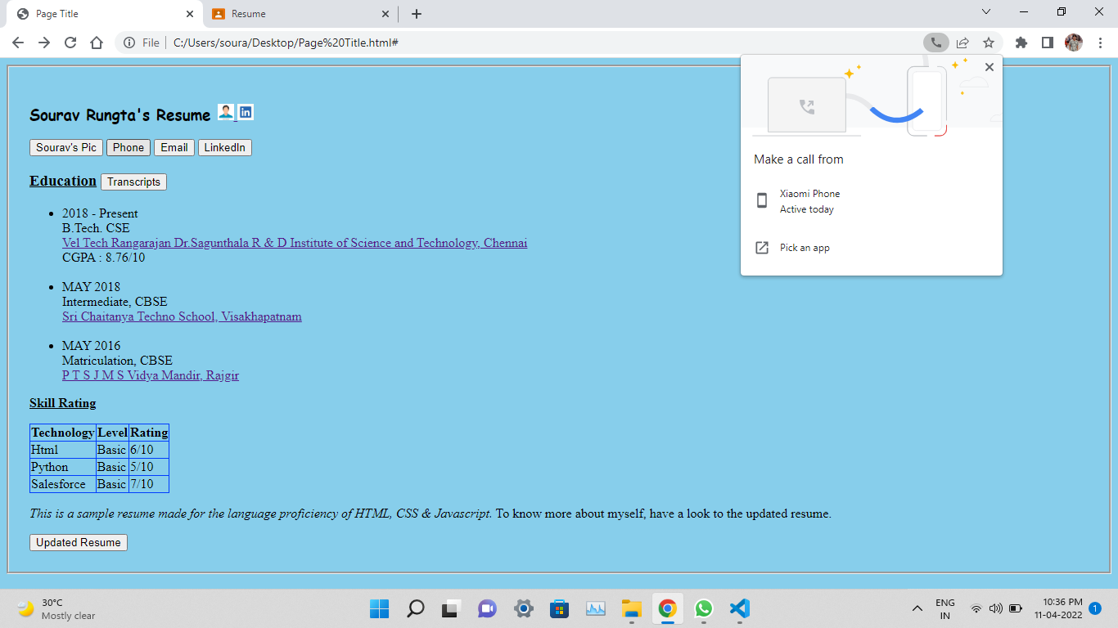

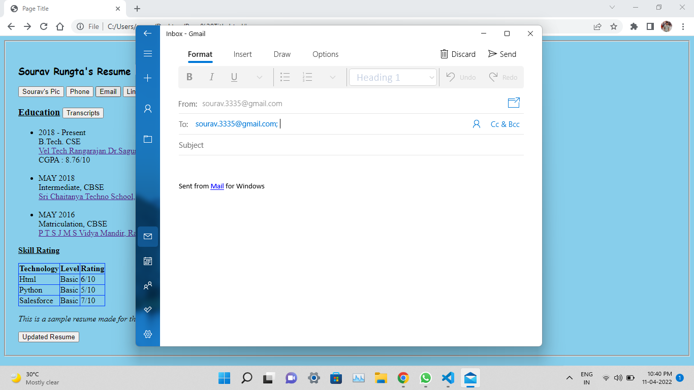

LinkedIn is opening with that button in new tab.

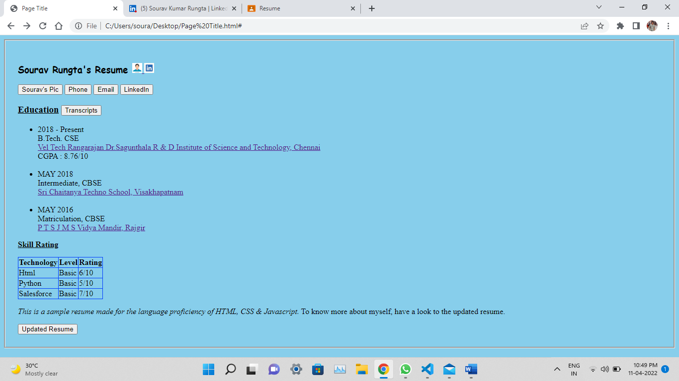

Transcripts works the same.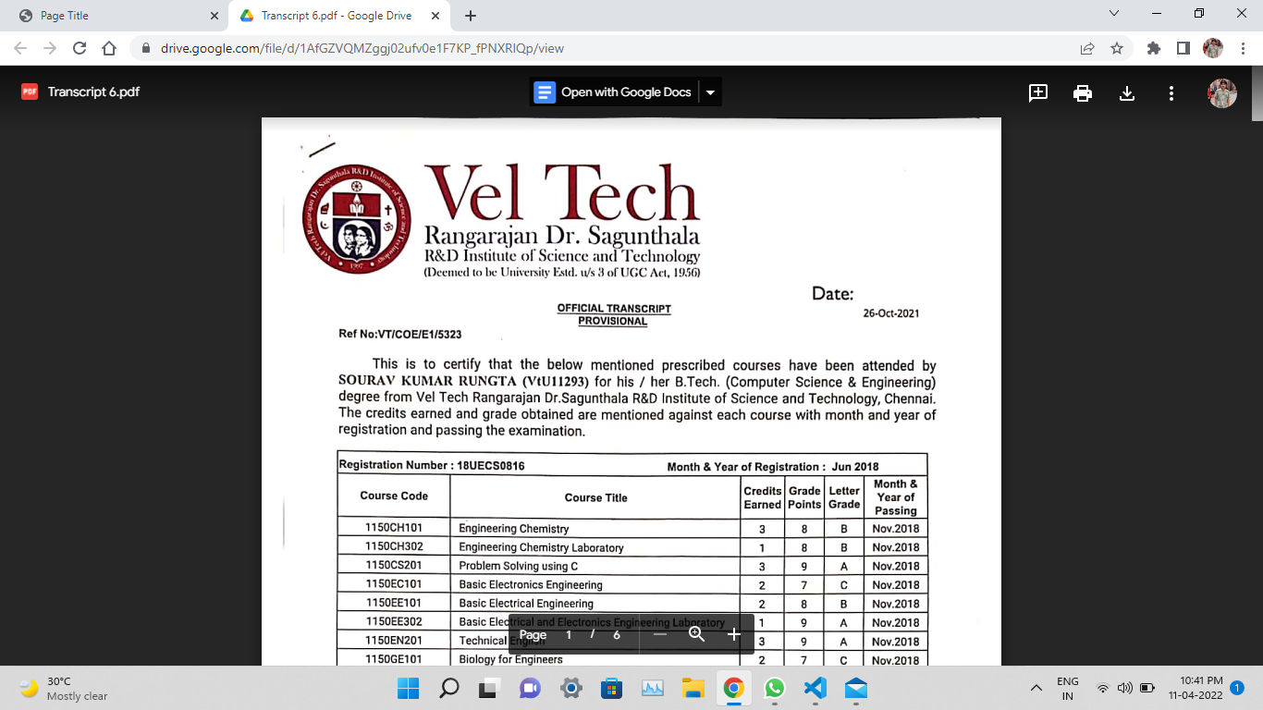

Whenever the cursor is placed in any of the college name, the backgound color changes to pink and after clicking it will redirect to the website.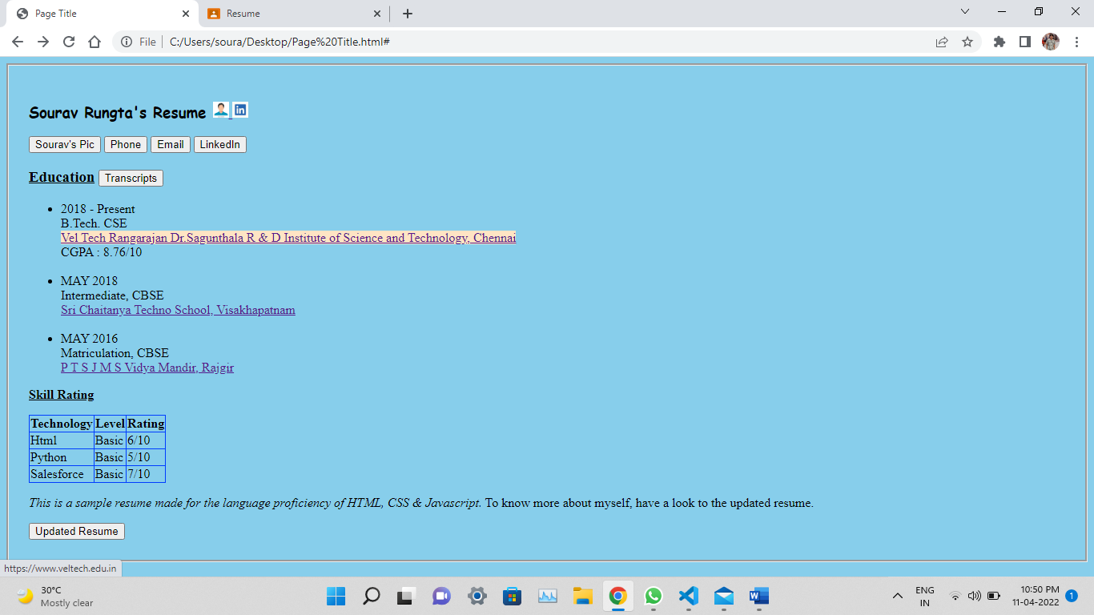

And at last same button with resume is attached.